Міністерство Освіти і Науки України

Кафедра Інженерії програмного забезпечення

Лабораторна робота №3

UI Testing

Виконала: ст.гр. ІП-16-1

Джус Ірина

Перевірила:

Бандура В. В.

м. Івано-Франківськ

2019 р

***Мета:*** Навчитися виявляти та виправляти проблеми та помилки, які виникають під час створення графічного інтерфейсу програмних продуктів.

***Виконання завдання:***

1. Тестування статичного калькулятора

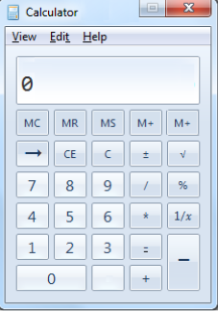

Помилки:

1. Відсутність кнопки «Згорнути» у правому верхньому кутку



1. Нижні підкреслювання під словами ‘View’, ‘Edit’, ‘Help’



1. Стрілка «Вперед» замість «Назад»



1. Повторення кнопки «М+»



1. Знак «=» розташований не по центру кнопки



1. Порожня кнопка замість кнопки із знаком «,»



1. Знак «-» розташовани на місці знака «=»

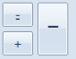

1. Тестування статичної сторінки календаря

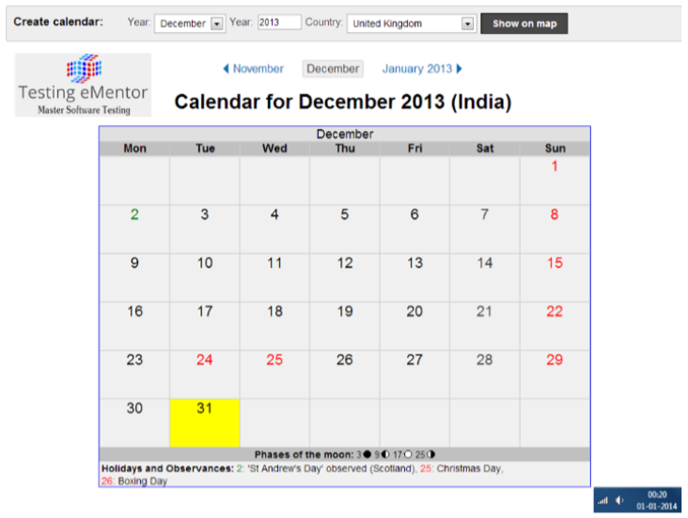

Помилки:

1. В заголовку календаря вказано, що обрана країна – Індія, в той час, як у випадаючому списку ‘Country’ обрано країну United Kingdom

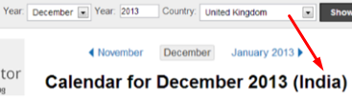

1. На календарі червоним кольором виділені наступні дати December 24, December 25, проте під ним зображено, що червоним чольром повинні бути виділені дати December 25 (Christmas Day), December 26 (Boxing Day)

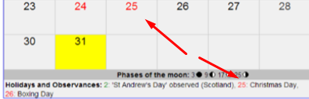

1. Слово ‘Year’ замість ‘Month’ біля випадаючого списку з місяцями року угорі екрану



1. Відсутня кнопка випадаючого списку у полі ‘Year’



1. Відсутній рік біля попереднього місяця



|  |  |  |
| --- | --- | --- |
| 1 | Is there any inconsistency in the UI?    (buttons disabled) | The disabled button should be grey color.  Text on the disabled buttons should be black color.  When the cursor hover the disabled button default cursor does not change to pointer. |
| 2 | Is there any inconsistency in the UI? | The button name should be written from the capital letter.  When the cursor hover the text field, default cursor should change to text cursor.  The button should be aligned with the text field. |
| 3 | Is there any inconsistency in the UI? | The button name should be written from the capital letter.  The button should be aligned with the text field.  If text field is disabled button should also be disabled. |
| 4 | How checkbox can be checked off? | Checkbox can be checked off:  -With clicking left button of a computer mouse;  -With tapping on a touchscreen;  -With the keyboard. |
| 5 | The gender selection is implemented on screen below. Please describe the weak points of this implementation and propose better way of implementation. | Since the choice is between opposite sexes the better way of this implementation is to create two checkboxes separately for Male and Famale or a radio button which will allow to choose only one alternant. |
| 6 | Please, propose improvements for the part of the screen below.  Requirement: if ‘no thanks’ checkbox is checked off other fields should be disabled | The checkbox name should be written from the capital letter.  Word “bunus” should be written like “Bonus”.  It would be better to use two radio buttons: «No thanks» and «Select two bonuses». Second option enable related checkboxes. |
| 7 | Please provide your recommendations regarding improvements of the part of screen below. | It is better to use one radio button “Accept” |
| 8 | Would a radio button be a better choice? (select between Portrait and Landscape mode, Portrait uses by default )  Screen shot of one check box labeled Landscape | In this example, the opposite choice from Landscape isn't clear, so the check box isn't a good choice.  The choices are not opposites so radio buttons are the better choice. |
| 9 | Is radio button the best choice?  Screen shot of Show and Don't show ratio buttons | In this example, the options aren't important enough to use radio buttons. It would be better to use only “Don’t show this again” checkbox. |
| 10 | Is it the best implementation of the part of screen?  Screen shot of check boxes aligned horizontally | The checkboxes should aligned vertically because the horizontal alignment is harder to read. |
| 11 | What is mixed-state for checkbox?  Screen shot of a solid blue Read-only check box | **Mixed choice** In addition to their selected and cleared states, check boxes also have a mixed state for multiple selection to indicate that the option is set for some, but not all, objects. |
| 12 | Can we use checkboxes as a progress indicator?  Screen shot of four check boxes showing progress | It is better to use progress indicator instead of checkbox in this case. |
| 13 | Can we use the selection of a checkbox to perform commands? | We cannot use the selection of a checkbox to perform commands. It is better to use buttons or icons. |
| 14 | Can we use the selection of a checkbox to dynamically display other controls related to the selected control (screen readers cannot detect such events)? | We cannot use the selection of a checkbox to dynamically display other controls related to the selected control (screen readers cannot detect such events). It is better to use radio button. |
| 15 | Can we use the selection of a checkbox to display other windows, such as a dialog box to gather more input? | We cannot use the selection of a checkbox to display other windows, such as a dialog box to gather more input. It is better to use buttons |
| 16 | Are there any inconsistency in the relationship between radio buttons and checkboxes?  Requirement: when ‘Custom’ radio-button is selected all checkboxes are enabled.  Screen shot: selected button, cleared check boxes | The subordinate check boxes aren't selected and don’t make their relationship to the selected option clear. |
| 17 | Is it the best implementation of screen?  Screen shot of nested radio buttons | It is better to use checkboxes instead of radio buttons to select options “In a new window” or “In a new tab.” |
| 18 | How implementation of screen can be improved?  Screen shot of redundant radio-button group label | It is better to avoid multiple repeating of common-sense words.  In this case it is better to delete header “Alignment:” and names of radio buttons should contain only directions of alignment. |
| 19 | Is it the best way of the controls’ location on the screen?  Screen shot of horizontal radio-button alignment | It whould be better to align controls vertically beause the horizontal alignment is harder to read. |
| 20 | Is it right to leave editable text boxes and drop-down lists enabled if they share the radio button's label? (See example). What requirement should be for the editable field?  Screen shot of Page range dialog box with text box | It isn’t right to leave editable text boxes and drop-down lists enabled if they share the radio button's label. |
| 21 | What is list-box, drop-down list, combobox? What are the two types of combobox? | A standard list box is a box containing a list of multiple items, with multiple items visible.  A drop-down list is a list in which the selected item is always visible, and the others are visible on demand by clicking a drop-down button.  A combo box is a combination of a standard list box or a drop-down list and an editable text box, thus allowing users to enter a value that isn't in the list.  An editable drop-down list is a combination of a drop-down list and an editable text box.  An editable list box is a combination of a standard list box and an editable text box. |
| 22 | There are numbers from 1 to 31 (day of month) in dropdown list. How we can select 5? | We can select 5 by clicking on it with a mouse or by pushing 5 on the keyboard. |
| 23 | There are numbers from 1 to 31 (day of month) in dropdown list. How we can change selection between 3, 30, 31 items? | We can change selection between 3, 30, 31 items by scrolling the dropdown list and clicking on items we need.  Another way is to click 3 three times on the keyboard. |

***Висновок:*** на даній лабораторній роботі було виявлено проблеми та помилки, кі виникли під час розробки графічного інтерфейсу.